Making a Linux Distribution
Build your own fork of Ubuntu and distribute it online

Edition 1.0
Copyright © 2022; Dakota “Kai” Lyons
Unless specified otherwise, all content in this book is licensed under the Creative Commons Attribution-ShareAlike (BY-SA) 4.0 International.
https://creativecommons.org/licenses/by-sa/4.0/
Unless specified otherwise, all source-code in this book is licensed under GPLv3.0
https://github.com/Ubuntu-Fork-Book/Licenses/blob/main/GPL-V3.0
All project source code can be found here:
https://github.com/Ubuntu-Fork-Book
Ubuntu is a registered trademark of Canonical Inc. This book does not claim to be endorsed by Canonical, and only uses the term Ubuntu in reference to the base operating system this book chose to support.

For Charlotte, Nana, Bob, Belle
And everyone else who has been there to inspire me and encouraged me.

Table of Contents
Chapter 1: An Introduction 8
Chapter 1.1: Welcome & Meet The Author 8
Chapter 1.2: Why make an Ubuntu fork? 11
Chapter 1.3: Why not Linux From Scratch? 13
Chapter 1.4: Pros and cons of Ubuntu 15
Chapter 1.5: Other distributions to consider 17
1.5.1: Arch Linux 18
1.5.2: Debian 19
1.5.3: Slackware 20
1.5.4: Independent Linux distributions 21
1.5.5: The BSD systems 22
1.5.6: Other non-Linux options 23
1.5.7: Custom kernels 24
Chapter 1.6: Developer needs and challenges 25
Chapter 1.7: Why you shouldn’t make an operating system 27
Chapter 2: Introducing Ubuntu 36
Chapter 2.1: The Reason for Ubuntu 38
Chapter 2.2: Ubuntu’s Release 39
Chapter 2.3: Ubuntu’s Growth 42
Chapter 2.4: The Unity Desktop 43
Chapter 2.5: Mobile Ambitions 45
Chapter 2.6: Modern Ubuntu 47
Chapter 2.7: Ubuntu Flavors/Remixes 48
Chapter 2.8: Distributions derived from Ubuntu 50
Chapter 2.8.1: Linux Mint 51
Chapter 2.8.2: Zorin OS 52
Chapter 2.8.3: Pop!_OS 53
Chapter 2.8.4: elementaryOS 54
Chapter 3: Build tools 58
Chapter 3.1: Why use a build tool 59
Chapter 3.2: Manual forking 61
Chapter 3.3: Custom build tools 62
Chapter 3.4: Build tools for Ubuntu 66
Chapter 3.5: Choosing a build-tool 67
Chapter 3.6: Avoid GUI tools 68
Chapter 4: Before the beginning 72
Chapter 4.1: System requirements 74
Chapter 4.2: Make VS. Shell 76
Chapter 4.3: Configurations 77
Chapter 4.4: What is a GRUB Modifications 80
Chapter 4.5: LTS VS Mainline 81
Chapter 4.6: Remix or fork 82
Chapter 4.7: What are we building? 83
Chapter 5: Fork using the Terraform Builder 86
Chapter 5.1: What is Terraform 87
Chapter 5.2: Ubuntu Remix Popularity 88
Chapter 5.3: Setting up your system 89
Chapter 5.4: Basic configuration 92
Chapter 5.4.1: Modifying the architecture 95
Chapter 5.4.2: Modifying the base/distribution version 96
Chapter 5.4.3: Changing the name of the distribution 98
Chapter 5.5: Package configuration 99
Chapter 5.5.1:APT Package Configuration files 100
5.5.2: Removing unneeded packages 103
Chapter 5.6: Adding packages 108
Chapter 5.7: GRUB/ISOLINUX configuration 110
Chapter 5.8: Building 114
Chapter 6: Fork using the Pop Builder 122
Chapter 6.1: Differences between Terraform 123
Chapter 6.2: Setting up your system 124
Chapter 6.3: Basic configuration 125
Chapter 6.4: Package configuration 126
Chapter 6.5: Adding packages 127
Chapter 6.6: Building 128
Chapter 7: Build tools for other operating systems 129
Chapter 7.1: ArchISO 130
Chapter 7.2: Linux Respin 131
Chapter 7.3: Linux Live System 132
Chapter 7.4: GhostBSD Builder 133
Chapter 7.5: Potabi Systems Builder 134
Chapter 7.6: FreeBSD Source 135
Chapter 8: How to continue 136
Chapter 8.1: Desktop Environments 137
Chapter 8.2: Kernel Versions 138
Chapter 8.3: Core Utilities 139
Chapter 8.4: Shells 140
Chapter 8.5: Applications 141
Chapter 8.6: Installers 142
Chapter 8.7: Open VS Proprietary 143
Chapter 8.8: Changing Base 144
Chapter 8.9: More than software 145
Chapter 9: Epilogue and Final Thoughts 146
Chapter 9.1: What we learned 147
Chapter 9.2: Is it still worth it? 148
Chapter 9.3: A thankless job 151
Chapter 9.4: Build an imagination 153
Chapter 9.5: To conclude 154

Chapter 1: An Introduction

Chapter 1.1: Welcome & Meet The Author
Welcome, and thank you for purchasing this book. After writing “Technology Sucks: A list of rants about technology most people don’t care, or even know, about”, I wanted to share the processes I have went through when making some of the work that inspired some of those rants.
Making an Ubuntu flavor/remix or just forking Ubuntu is an interesting process that can teach a lot about project management, while also benefiting the community with your ideas.
While many will argue that this book “promotes the problem of fragmentation”, I disagree. First, fragmentation is not an “issue”, just an outcome of life. Second, to consider it an issue is debatable at best.
Fragmentation comes with its fair share of issues, but that wont stop developers from wanting to make something new. Plus, it can be beneficial.
In all honesty, the vast majority of “garbage distributions” that offer nothing to the community fall into obscurity, rarely ever making too much if a problem. A book like this could teach a newbie indie-developer how to make something special, and make the next big distribution of Linux.
While I used to be of the mindset that the worthless distributions would cause many issues for “the next big distribution” to struggle to reach the top, in truth this idea has been proven wrong time and time again. If someone has something to offer, eventually people will notice.
This doesn’t mean the process isn’t difficult. If you want to make a “good” distribution and have it take the industry by storm, be prepared to have a lot to offer. As simply packaging good software with a distribution doesn’t mean your distribution will be good.
This book will not go over the development of software, nor the packaging for the Debian package format – which Ubuntu uses. These skills are absolutely necessary to making a proper Linux distribution, but that is not the purpose of this book.
The specific purpose of this book is to take Ubuntu and make a barebones distribution with existing packages in the Ubuntu repositories.

Chapter 1.2: Why make an Ubuntu fork?
There are a million and one ways to make a Linux distribution. Methods include Linux From Scratch, or forking a different distribution or even different operating system.
The purpose of this book is to teach two tools to fork Ubuntu. The reason to fork Ubuntu when making a project like this is because of the diverse efforts by many to make Ubuntu as user-friendly as possible.
While the purpose of your distribution may be better filled by another base – or no base at all. Ubuntu, however, has a strong ecosystem that allows beginners to make something amazing.
An Ubuntu fork is great to learn the basics, without having to jump into more complicated subjects in making an operating system.
Not that the complicated aspects of making an operating system isn’t important, but you have to walk before you can run.
Ubuntu is great as a learners tool for making a distribution because Ubuntu has a large existing package repository, full of software that a developer can use to make their life easier, compared to either compiling everything from source, or using a rolling release bleeding edge system where applications might break out of nowhere due to package versions.
Using Ubuntu also gives users of a distribution a large variety of options when it comes to software, and software versions – as a developer can package newer versions of a piece of software for Ubuntu if they so choose.

Chapter 1.3: Why not Linux From Scratch?
It doesn’t similarly fit the purposes of this book. Plus, Linux From Scratch is it’s own valuable resource for learning Linux at a lower level.
While in many ways, Linux From Scratch by Gerard Beekmans is a great resource for learning the lower-level of Linux itself, it isn’t quite designed for distribution of a project.
However, it is an arguable prerequisite read for any aspiring Linux developer, as it teaches many fundamental aspects of the core of Linux itself. Gerard Beekman’s Linux From Scratch book is freely available online, with print versions also available. It supports both Systemd and non-Systemd versions, which are concepts a distribution developer must understand and make a decision of.
With Linux From Scratch, a developer will learn the core of Linux itself, but another reason that this book could be valuable outside of Linux.
This book, while focused on Ubuntu, also has a special quick overview of my own Potabi System’s builder, as well as the GhostBSD builder to show how the tools used in this book can be similarly implemented into other distribution development.
AutoLFS or ALFS is already a topic within the Linux From Scratch community, as a way to automate the build process of the Linux From Scratch book for developers who run Linux From Scratch on their personal computers.

Chapter 1.4: Pros and cons of Ubuntu
It’s not fair to consider Ubuntu “perfect” as an option for all distribution development. While I choose FreeBSD as a base, I do have experience with the two Ubuntu build tools used in this book. One with actual projects, the other for small-scale experimentation. Both of which are valuable to understand, as both use different methods. Here are three major pros, and three major cons.
Three pros of forking Ubuntu:
- Large community full of information that can support any budding developer.
- Supports the vast majority of Linux-supported software, including libraries that makes your applications work well.
- The long-term support model makes development a little easier.
Three cons of forking Ubuntu:
- Developers have less control over their distribution as Canonical has its own vision for the operating system, a general con of forking any distribution.
- While popular, Debian packages do have their fair share of flaws and complexities that don’t necessarily exist on other package managers that have negligible differences in most supported software.
- Ubuntu’s package repositories aren’t known to have the most up-to-date software. In some cases this is negligible or even a benefit, but in most it means the developer using these repositories are using slightly out-of-date software.

Chapter 1.5: Other distributions to consider
This book still argues the best place for experimenting with a new idea is on Ubuntu, as others require more knowledge, skill, fewer resources, and/or have some other caveat. However, for a flagship project, these all are valuable options.
These options aren’t all Linux, as some projects may be better suited with other kernels, or even custom kernels.
The next few subchapters describe six major choices an operating systems developer has option to choose. These include Arch Linux, Debian, Slackware, being an independent distribution, the BSD systems, a small list of other non-Linux options that exist, and going all in on a custom kernel and possibly even userland.
None of these are small tasks, even forking Ubuntu. Each come with difficulties, and challenges a developer must face.

1.5.1: Arch Linux
One of the more popular option for Linux distributions to fork, Arch Linux is a very versatile option for developers.
Arch is known as a rolling-release bleeding-edge distribution, meaning it’s the best when it comes to the most up-to-date software. Not to mention, Arch Linux is a growing distribution market, with it being a hot topic where distributions like Manjaro being bigger than even popular Debian/Ubuntu systems.
With base Arch Linux being a long processes, with complicated aspects like partitioning (usually done by the system installer on other operating systems) being done manually, a developer could make an “Arch Installer”, a tool dedicated only to installing Arch Linux itself, though not an operating system by itself.

1.5.2: Debian
Debian is the base distribution that Ubuntu forks. Yes, Ubuntu itself is a fork. Debian is the second oldest, currently active, Linux distribution, first released in late 1993.
Debian is a popular choice, being used as a base from Ubuntu, Devuan, Linux Mint Debian Edition (the main edition being a fork of Ubuntu), and many others.
While Ubuntu is a more popular option for both forks and users, its work is thanks to Debian itself. Debian is versatile, and supports basically every single application designed for Ubuntu – as Ubuntu uses Debian’s packaging format.
Debian is more difficult to use than Ubuntu, but still is a valuable option for operating system developers.

1.5.3: Slackware
Slackware is an option, but arguably not necessarily the best one for most developers. It’s the oldest active-development Linux distribution on the market, older than even Debian.
Slackware is maintained by one person, Patrick Volterding, who first released the operating system in June 1993, before Linux 1.0 was even released.
Not many operating systems use Slackware as a base, however, it doesn’t mean they don’t exist. SUSE Enterprise Linux – the parent distribution of OpenSUSE, a popular desktop operating system – partially forked Slackware Linux early in its development.

1.5.4: Independent Linux distributions
An independent Linux distribution is a Linux distribution that does not fork the developments of another system. Essentially, taking the Linux kernel, and use either an existing or custom made userland to create an operating system.
This is great as an option because this allows a developer of an operating system to use Linux, while still not needing to worry about how systems like Ubuntu move forward.
However, this is far more difficult, as it really is just building Linux From Scratch, which is far more complicated than forking an existing system. While beneficial, it may not be required for many operating system developers.

1.5.5: The BSD systems
There are four main BSD systems: NetBSD, FreeBSD, OpenBSD, and DragonFly BSD. While having a smaller userbase, the BSD systems – especially FreeBSD and derivatives like TrueNAS – are still popular in enterprise distributions.
Not to mention, desktop solutions that act similarly to Linux like GhostBSD are possible to make, and be fairly popular.
The BSD systems come with a few benefits over Linux, as BSD systems use their own kernels. This allows them to more strictly manage how the system works, and make a better userland/kernel experience for systems to fork.

1.5.6: Other non-Linux options
Non-Linux options for existing systems to fork do exist, however, with major caveats. Not the least of which being application support and user-base.
While not necessarily a killer for these projects, it does create difficulty for a systems developer.
Options like Haiku are still moderately popular, with decent application support, and having a decent size user base. Others like ReactOS offer a very unique base that does what few others actually can support – though having notorious issues with stability.
There is a wide range of options in non-Linux options, but they all come with various caveats, difficulties, and more. However, they may suit your goals better than other options.

1.5.7: Custom kernels
Custom kernels are a very difficult thing make, and is something that requires some level of skill and lots of prerequisite knowledge especially in assembly language, CPU architectures, hardware support, and more.
Using an existing kernel like Linux allows developers to skip the difficulty of these topics, but if Linux, BSD, and every other preexisting option fails your purpose, learning how to make a custom kernel may be your best option.
Kernels can actually be made in a wide variety of languages, but involve so much work it may be required to find a few development partners who are willing to help make a custom kernel with your operating system.

Chapter 1.6: Developer needs and challenges
It’s important to note that making an operating system is no small feat of efforts. Working alone is basically not an option for most, especially with the massive amount of work a distribution would need to be “unique” including custom desktop environments, applications, graphical software manager, graphical installers, etc.
For all intents and purposes, this book will not elaborate more on these advanced topics, as it is a set of challenges that the developer themselves need to understand and work with on their own, as there is no one solution to a given challenge.
Even building a fork of Ubuntu has many different avenues and options, of which this book focuses on two of them.
In truth, a professional operating system like Pop!_OS and Ubuntu need tens of developers at least. FreeBSD, a non-Linux operating system who’s development of everything from the kernel to the userland has four hundred authorized committers.
Microsoft Windows, the world’s largest operating system also has a lot of developers. It’s believed anywhere from five hundred to two thousand developers worked on the Windows 7 operating system, while the exact number is debatable.
These challenges come even with the most generic Linux distributions, as even changing a few wallpapers, adding a few existing applications, and changing some default settings can take hours or days to properly develop only using off-the-shelf options.

Chapter 1.7: Why you shouldn’t make an operating system
With all of these options, and great ideas you have in your mind, here’s why you shouldn’t actually make an operating system – yes, I am serious.
Even simple projects like the one this book offers the tools and concepts to make, it’s still not a good idea to make an operating system. There are a million reasons for this, but here are a few major ones.
The market is cornered by Microsoft, Google, and Apple. With these multi-billion dollar companies, who sometimes reach trillion dollar status, it is near impossible to compete with these major companies.
Often, developers have to join them in order to survive as projects or even companies. It is an up-mountain battle.
Another thing to note is one talked about many times in this first chapter alone. Building an operating system often requires multiple team members, or employees if you are daring enough.
Building an operating system is a major undertaking, not suited for the faint of heart. While any Joe Shmoe can make a website, a video game, or even basic mobile application, an operating system is not that.
There is the issue of security when it comes to single-developer operating systems, as only one person is really responsible for making an operating system, plus fixing bugs, exploits, and vulnerabilities.
This often leaves most small operating system projects to be hobbyist systems only, especially when it comes to custom kernel and most non-Linux solutions like BSD, Haiku, ReactOS, and others. This even includes the fact that FreeBSD has hundreds of active contributors and developers, with a major non-profit also there behind it.
To make a proper operating system also requires a large amount of development if a developer chooses not to use off-the-shelf options – which isn’t always a solution.
There is the user land, which is basically the set of libraries and applications that turn a kernel from zero to hero. By itself, the kernel is useless, but the user land, which includes core utilities, makes the kernel functional with purpose.
Making a user land is not making one application, it’s making several, which is not necessarily a good option for most developers.
Even taking the easy way out and forking Ubuntu needs its own book to describe how and why to do it, with preexisting simplified tools.
While these tools make it possible for one developer to make an operating system, take it from someone making a forked operating system.
As mentioned, I make the Potabi Systems suite of operating systems, which includes desktop, server, and mobile developments. The process of even getting to the fourth beta version of the desktop, which even the beta four release doesn’t even have an installer application ready for users to actually install the system, took nearly a year of development, and I even mostly forked the GhostBSD builder to get what I currently have as an operating system.
Plus, unlike making a website, app, or even video game, making an operating system requires a mountain of computer science knowledge. Without which it’s near impossible to make a valuable operating system, and even with, takes tons of time and effort for what is really a thankless effort.
One thing that operating systems developers, and even Linux distribution maintainers don’t get a lot of is thanks. Operating systems to most people look like magi. People often think when there is an issue it’s easy enough to fix, which isn’t true. A small kernel bug could take weeks to fix after discovery, if the developers or contributors discover it before it causes a ton of issues. These issues could even be small edge-case scenarios, but still need fixing lest a major corporation’s systems go offline
If you are willing to fight an up-mountain battle with everything from major corporations to small, but established hobbyist systems. If you are willing to fix small edge-case scenario issues. If you are willing to spend many sleepless nights just fixing small bugs that other apps, websites, video games can ignore – but you can’t – just for that fix to be a small footnote of other changes, improvements, and fixes people don’t really thank you for, then maybe you are right to make an operating system.
This book is supposed to be an introduction to those who want to work on something big, in the smallest way possible to get an understanding. Distribution development isn’t for everyone, and that’s a good thing.

Chapter 2: Introducing Ubuntu

Ubuntu being the base has a long and interesting history. This chapter focuses heavily on the history of Ubuntu, including major changes like the Unity desktop.
Understanding the history of your base can give you an idea of why it exists, what they have worked on in the past, what worked, what failed, and where its going in the future.

Chapter 2.1: The Reason for Ubuntu
Ubuntu was founded and built in 2004, a year where the Linux desktop was lacking. At the time, Linux was complex and difficult to use, even compared to modern Arch Linux.
At the time, Slackware, Debian, SUSE, Red Hat, Enoch (later Gentoo), had existed in some form, but were not considered “user-friendly”.
Canonical was founded in March, 2004 by Mark Shuttleworth in the United Kingdom. Ubuntu would release in October the same year under the code name Warty Warthog.
Mark Shuttleworth named the operating system Ubuntu after the Zulu, where ubuntu means “humanity”

Chapter 2.2: Ubuntu’s Release
The first version, 4.10 Warty Warthog, was a revolutionary distribution of Linux on release. Being designed with a user-first philosophy, and with good branding in the versioning name alone.
Using GNOME 2 – which after GNOME 3 would be forked to make MATE – Ubuntu 4.10 would be the first version, with a new release every six months.
It’s release would have been, at the time, the – or one of the – easiest use Linux systems of its time.
As a first release, the operating system was not yet polished, but came with the basics – browser, office, image editor, and more. 4.10 would be supported until April 2006.
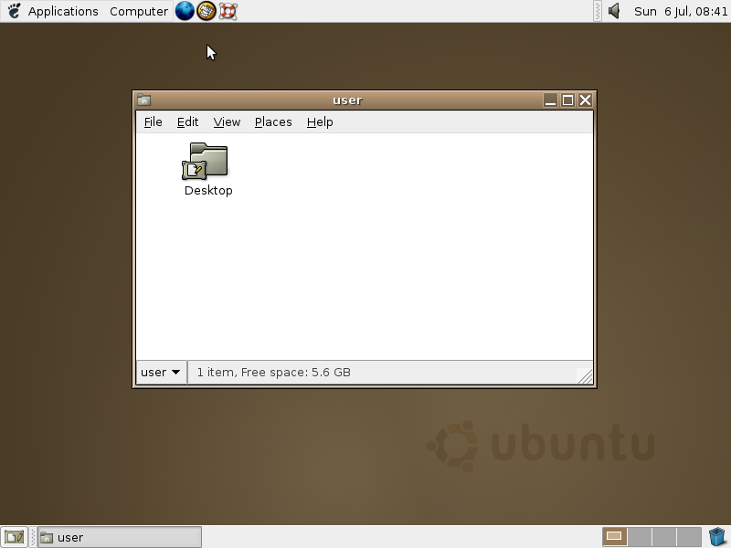
Ubuntu 4.10
By The original uploader was Altonbr at English Wikipedia. - Transferred from en.wikipedia to Commons by Shizhao using CommonsHelper., GPL, https://commons.wikimedia.org/w/index.php?curid=7589578

The naming scheme for versions is descriptor plus an animal name, both of which sharing the first letter.
Its next release 5.04 Hoary Hedgehog, would continue the legacy Ubuntu built for itself in its first version alone.
Canonical would make an error in its release schedule, due to its first – and to date only – delayed release, Ubuntu 6.06 Dapper Drake, which was the first LTS release, which would come every two years.

Chapter 2.3: Ubuntu’s Growth
After every release, it seemed as if Ubuntu would be unstoppable. Ubuntu was a pioneer of many technologies, and was desktop focused at the time, and directly competing with Windows – then at its popular Windows XP release.
Many Linux distributions would start following Ubuntu’s footsteps. While using GNOME, the first derivatives Kubuntu (first released alongside 5.04), Xubuntu (first released alongside 6.06 LTS), were some of the first flavors of Ubuntu.
Later, several remixes and flavors – which will be elaborated on in chapter 2.7, would continue to appear.

Chapter 2.4: The Unity Desktop
With the controversial release of GNOME 3 release in 2011, Canonical decided it was finally time to make their own desktop environment. GNOME had its new design since 2008, and Canonical rushed a new desktop environment’s development and released Unity in 2010, a year before GNOME 3.
The release of the Unity desktop was not well received, its first version being buggy, and it was so unpopular that a remix would appear called Ubuntu GNOME, to replace Unity on Ubuntu with the GNOME 3 desktop environment.
While not immediately popular at the time, the Unity desktop would later be picked up by the UBports team and renamed to the Lomiri desktop, and is primarily built for UBports’ continuation of the Ubuntu Touch operating system elaborated on in chapter 2.5.
The desktop environment is solemnly found outside of the UBports sphere, and projects actively aiming to support a Lomiri desktop experience on Linux.

Chapter 2.5: Mobile Ambitions
As mentioned in chapter 2.4, Ubuntu Touch was created by Canonical to support smartphone devices, including Canonical’s own device, the Ubuntu Edge Phone.
While the Edge Phone would never release, it did raise twelve million dollars on IndieGoGo.
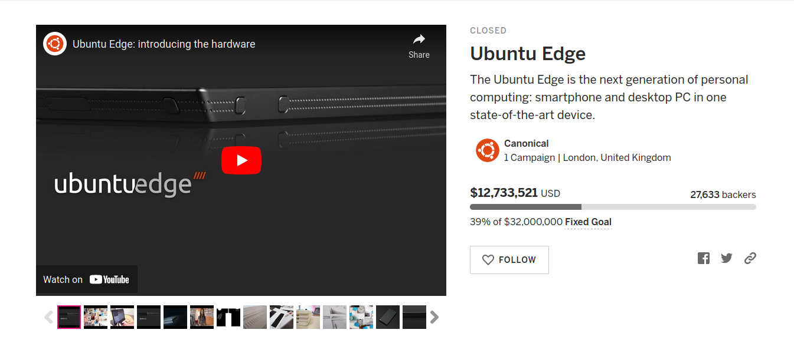
Ubuntu Edge IndieGoGo
Canonical’s project’s failure marked an arguable downfall in the quality of Ubuntu, at least according to many users.
The Ubuntu Edge Phone has a goal of thirty million dollars on the IndieGoGo crowdfunding platform, but with only a little over a third of the funds raised – still being a lot of money in many regards – Canonical abandoned the project.
It is argued that because of this failure, Canonical would later start focusing less on the desktop operating system in favor of the Ubuntu server versions, which is one of the most popular on the market alongside SUSE and Red Hat Enterprise Linux.

Chapter 2.6: Modern Ubuntu
Ubuntu in 2022 runs the GNOME 41 desktop environment. While the GNOME 4X series has some criticism, Canonical doesn’t seem as interested in maintaining the desktop operating system.
Every release on the desktop continues to seem more similar from the last, to the next, with minimal changes in the core utilities outside of updates and mild changes.
Focusing on server seems to be Canonical’s focus, especially with Ubuntu Server being available on practically all major server platforms, and it probably is where Canonical earns most of its money, as the desktop earns most of its money through donations.

Chapter 2.7: Ubuntu Flavors/Remixes
An Ubuntu flavor is a derivative of Ubuntu that does not change much of the operating system – usually only the desktop environment, or with a set of modifications to suit a specific purpose.
- Kubuntu: Ubuntu with KDE
- Xubuntu: Ubuntu with XFCE
- Lubuntu: Ubuntu with LXQt
- Ubuntu Kylin: Ubuntu with a custom desktop environment (UKUI) for Chinese users.
- Ubuntu MATE: Ubuntu with MATE
- Ubuntu Budgie: Ubuntu with Budgie
- Ubuntu Studio: Ubuntu for multi-media creation.

A remix of Ubuntu serves a similar purpose but does not have official recognition from Canonical, usually due to the development being too early.
Projects include – but are not limited to – Cinnamon Remix, UbuntuDDE Remix, Ubuntu Unity Remix, Ubuntu Web Remix.
While these remixes may be web developed, Canonical usually requires a few releases of the remix to come out before becoming an official flavor.

Chapter 2.8: Distributions derived from Ubuntu
There are many derivatives of Ubuntu, but there are a few notable ones. Knowing how a different project operates is just as important as knowing how your base operates, as well as how your own project operates.
To see what works and what doesn’t is an important process in developing an operating system.
All of these are forks of Ubuntu, but each has a different goal, process, and else-what. There are many others than this, and two of these are where the builders this book works with originates from.

Chapter 2.8.1: Linux Mint
Linux Mint has an XFCE and MATE version, but also supports its own desktop environment that forks the GNOME 3 desktop called the Cinnamon desktop environment.
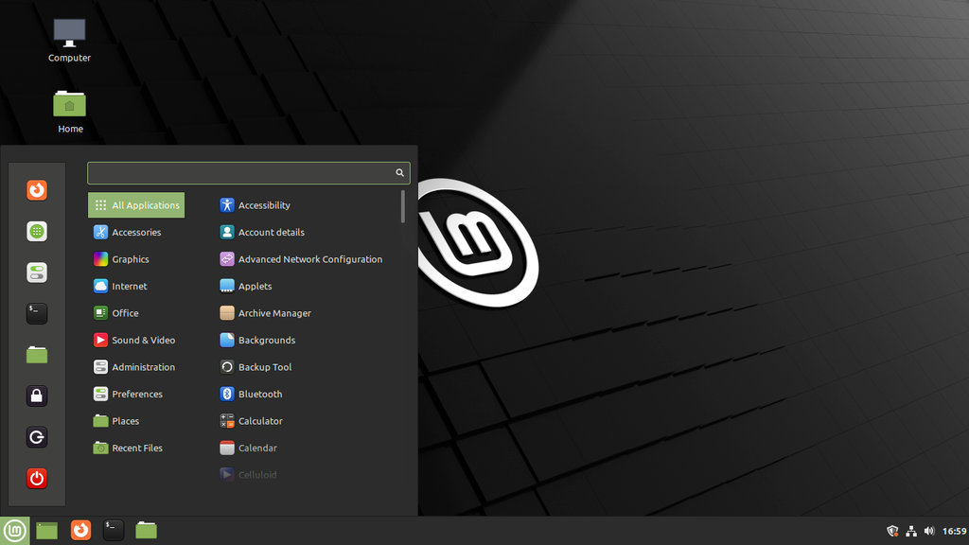
By Leonsk29 - Own work, CC BY-SA 4.0, https://commons.wikimedia.org/w/index.php?curid=114119791

Chapter 2.8.2: Zorin OS
Having versions with both the GNOME and XFCE desktop environments, Zorin OS is an Ubuntu-derived distribution.
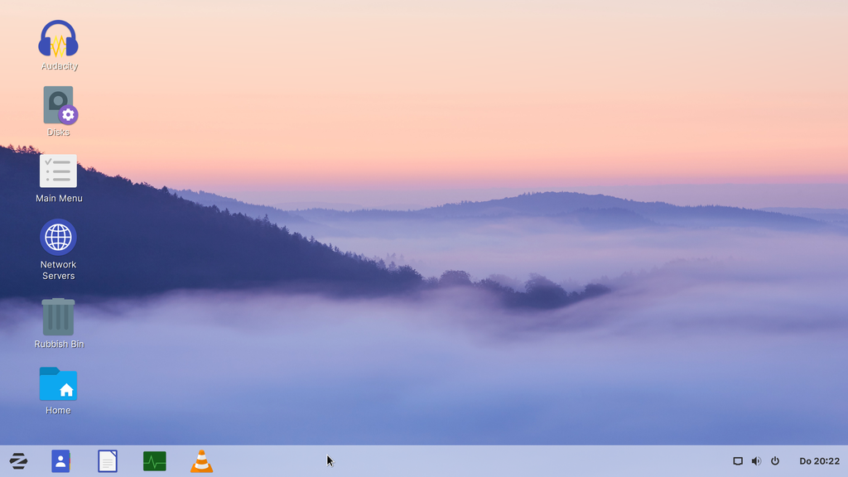
By OS by Artyom Zorin/Screenshot by PantheraLeo1359531 - Zorin OS Education 15.3 x64, GPL, https://commons.wikimedia.org/w/index.php?curid=101320854

Chapter 2.8.3: Pop!_OS
This distribution of Linux is where the origins of the pop builder in chapter 6 originates from. Currently using the GNOME desktop environment, they are working on their own custom desktop environment known as COSMIC.
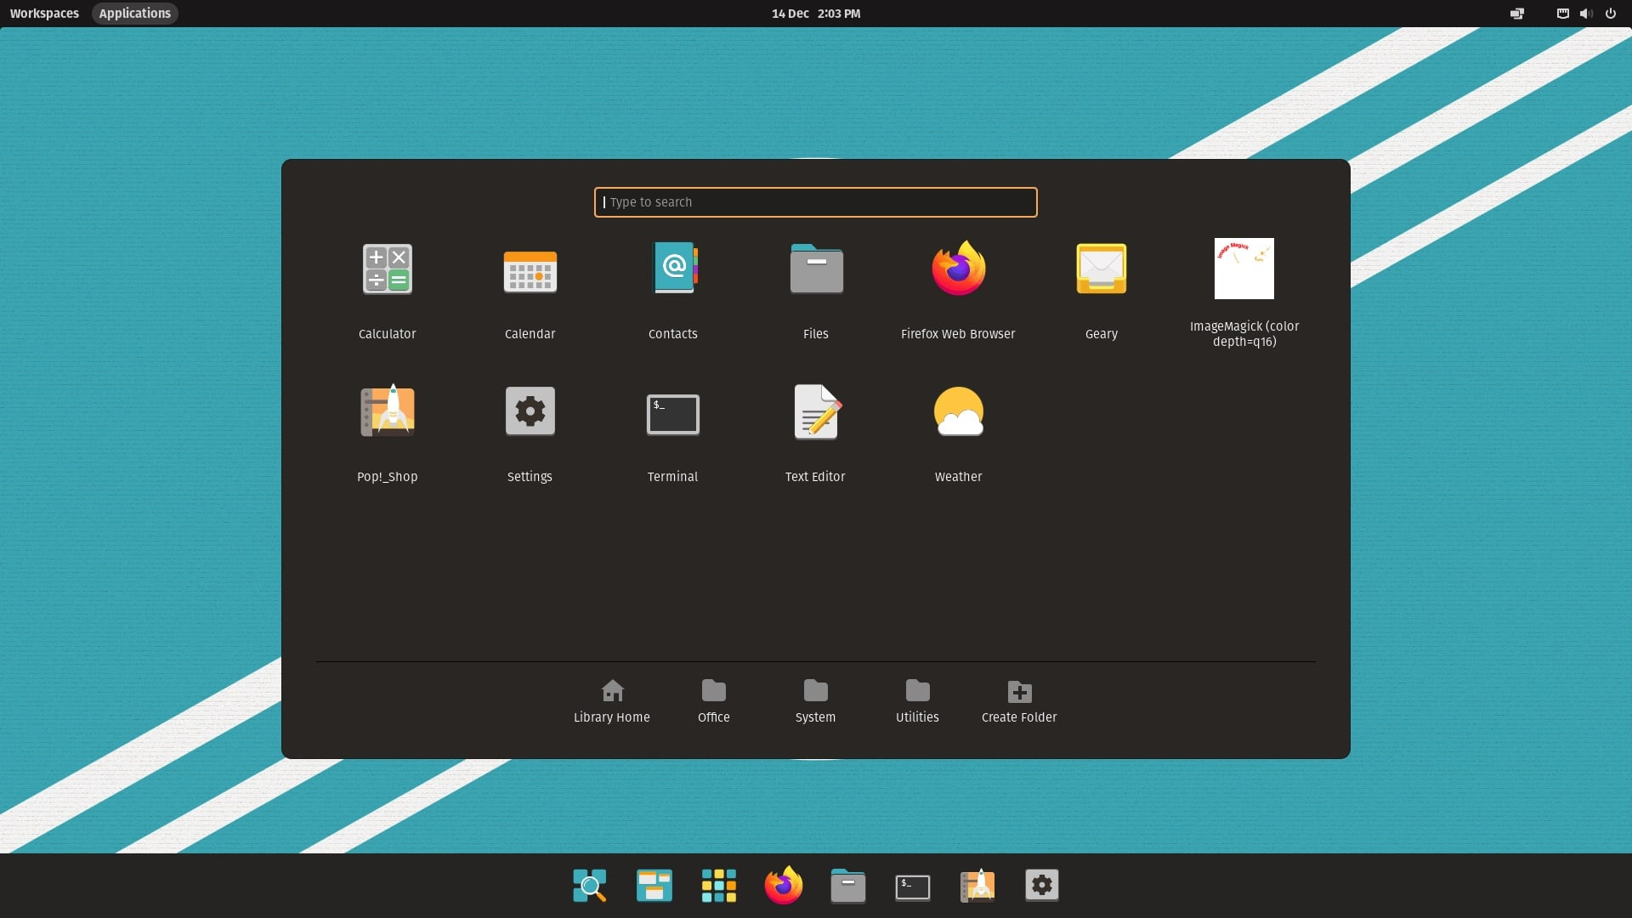
Credit OMG! Ubuntu!

Chapter 2.8.4: elementaryOS
Using the custom desktop environment Pantheon it is the origin of the terraform builder – which would later be modified by the Ubuntu Budgie team, which this book uses.
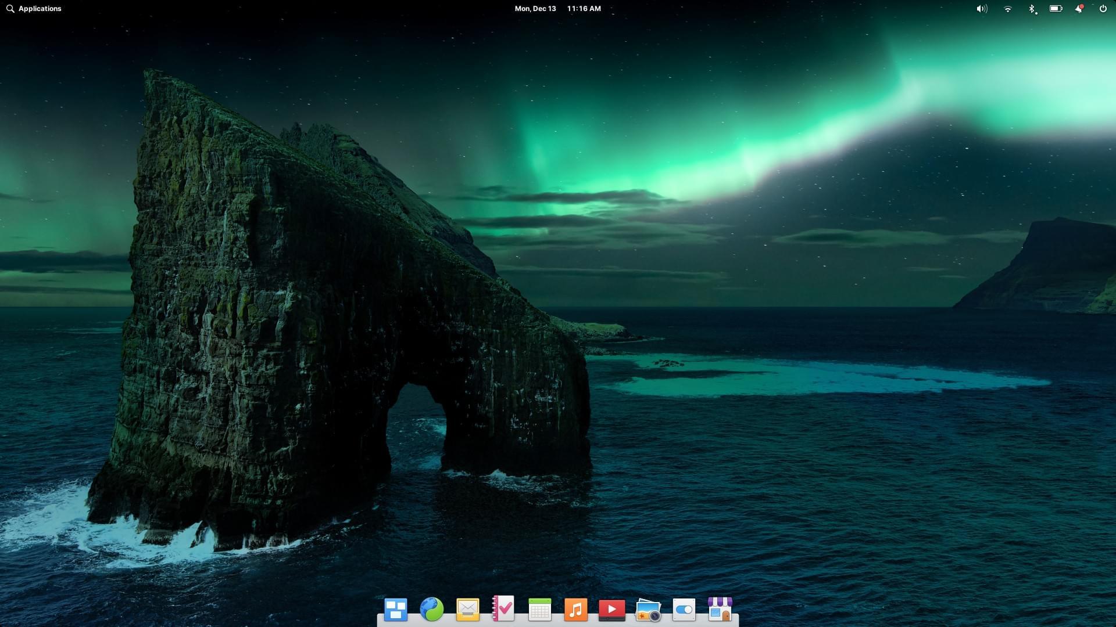
Credit elementary.io

Chapter 3: Build tools

Chapter 3.1: Why use a build tool
Using a build tool is generally good idea because it’s difficult to manually create a fork of a distribution of Linux, for the same reason people who run through the Linux From Scratch book created Automated Linux From Scratch (ALFS).
A goal of any developer is to make the processes of developing software easier. This is why developers solemnly use Assembly code for most applications, and why C has been replaced by a plethora of easier programming languages like Go, Rust, Python, and others.
Manually building an operating system without some form of automation is next-to impossible in the modern era, as it would really involve writing ones and zeros for each individual bit in what are currently multi-gigabyte operating systems, with 1 gigabyte being an unreasonably large amount of bits, of which would be impossible to write by hand in a timely manner.
When most people say building an operating system manually, they usually mean with minimal automation in the final build steps including compilation of the kernel, core utils, and other software.
A build tool manages that compilation, and makes it far easier to build a Linux distribution, even when running from scratch.

Chapter 3.2: Manual forking
Manual forking usually involves a long, complicated process of taking the operating system and manually running shell commands to compile software into a mounted system. While not impossible to do by hand, it is impractical.
With some operating systems like FreeBSD, a manual fork is a lot easier to do by hand, but build systems are still a recommended measure.
When manually forking the system, the system developer needs to worry about all aspects of the operating system and how they are compiled. While still possible, it’s easier to have a build tool do the work for the developer.

Chapter 3.3: Custom build tools
A custom build tool is arguably one of the biggest, but more important aspects of building a distribution, depending on purpose.
All build tools are custom, but to build one yourself you need to know the steps you want to take to first mount the operating system into a drive, then add software to your hearts content.
A custom build tool may actually benefit from running on a containerized system, as it allows the operating system on the desktop to run without damage to the users operating system itself, while usually being a Linux system.
Running in a container does present problems of extracting the ISO file – the final output of a build tool.
This, however, is fairly negligible of an issue, as most container systems like Docker and Kubernetes – two of the most popular options – have systems in place to extract files from a container.
While usually a manual task, this can be automated to an extent.
There is also the option of building in a virtual machine, though it is with its concerns. Especially when it comes to the extraction, as it is either far more difficult to extract the file, to borderline impossible without a system like SSH.
Running on a virtual machine is not a valuable alternative to building on a container, or otherwise a dedicated build system. A dedicated build system comes with a few of the same problems as running on a virtual machine, but having the advantage of having the ability to manage the operating system’s build tools on the actual host operating system itself.
While running a dedicated build machine is not possible for everyone, it is still an option for those who wish for it to be. It will mean either a new machine, or an old machine, has to be fully dedicated to the build process.
It is not recommended to run a build tool directly on the a daily driven host operating system, because it can make permanent, damaging modifications if something goes wrong.
One of the best ways to make a builder would be to have it run through a partition on a dedicated computer, or through a container for the system itself.
The reason to run it through a partition, rather than files, is because – especially on Linux, where there is no MDConfig to save the day (I have learned this the hard way) unlike on FreeBSD, so there has to be a dedicated partition.
While a mount to a non-drive is optional, it’s difficult on Linux. On FreeBSD, there is the MDConfig tool, which can create a vritual /dev/md0 drive that a generic .img file can be connected to.
While a tool like this could be available for Linux, it is still arguable that running via a mounted drive such as /dev/sda which can either be a dedicated mount on the hard drive or a mount from a USB drive, CD/DVD Read+Write disk, or otherwise storage available to the developers.

Chapter 3.4: Build tools for Ubuntu
For Ubuntu, there are more build tools available for it, than one might originally guess there being.
Anything from Terraform and Pop Builder – both are the main build system for this book – and graphical systems like Cubic builder.
Whether using a build tool here, building your own, or using another option, there are a few things to worry about when it comes to the development of an operating system.
Some tools are better for developers, others for other purposes, and ones that have major issues with being too manual like Cubic.

Chapter 3.5: Choosing a build-tool
Choosing a build tool comes to asking many questions.
If you want a purely shell-based installation method, Terraform builder is your friend. If you want a Makefile build tool, then use the Pop builder.
Of course, every system has different needs, so maybe a build tool like Linux Live System, which takes the current system and removes the unneeded files to create an ISO may be part of the operating system development experience you build for your self.
Choosing a build tool ultimately comes down to opinion, and what is needed to be done to the operating system to make it whole. Sometimes, a build system has to make compromises for that purpose.

Chapter 3.6: Avoid GUI tools
A graphical build tool seems user friendly, but ultimately undermines the purpose of a build tool – to automate the process. While a graphical overlay to a build tool might seem better, it still requires a decent amount of manual work, of which the operating system developer should be aiming to automate.
This includes the selection of a base system version, which in a system like Cubic – a graphical builder – would be done manually by the developer, when it would be easier to automate that process.
Avoiding a GUI tool just means avoiding something that takes more work than it needs. A developer would normally be working in files where text is needed anyways, why waste time using a graphical tool for the most difficult part of the process? Well, there are some benefits to the use of a graphical tool, but they are far and few between.
There is no such thing as a perfect, nor absolutely worst option to build any operating system. Some developers may use the graphical tool for it may do some work the developer would otherwise not understand in a shell/Makefile experience. However, this is an excuse, and hinders developers more than help, as they are ignoring concepts that would be beneficial to know.

Chapter 4: Before the beginning

No one can rush into a project, and this book is intentionally designed to help a new developer build the distribution of their Linux dreams.
There are many things a developer needs to know before beginning, which is the purpose of this chapter.

Chapter 4.1: System requirements
Having a system that can run a modern Linux operating system, while having space to spare is theoretically enough to build an operating system. A developer could build a Linux distribution on a Raspberry Pi 3B+, but the hardware limitations are still important to note.
This book recommends the following hardware configuration. If your computer does not meet the system configuration, don’t worry, it just means it will take far longer and have higher likely-hoods of crashing or extreme throttling.
- 4 Core CPU
- 12 GB RAM
- 1 TB storage

While there is no minimums, this book is build with what would be considered by most to be the absolute minimum required to build an operating system – except in terms of storage space, because you also need to test the operating system, including installation.
The minimum recommended spec is:
- 2 Core CPU
- 8 GB Ram
- 100 GB storage including room for the host operating system, and optional – depending on build tool – partition space for distribution development specifically.

Chapter 4.2: Make VS. Shell
Compiling a Makefile is different from running a shell script. Notice the words compiling, and running.
A Makefile is a set of instructions to build some software – not just operating systems – and usually includes items such as compiler configurations, and different functions.
Similarly, a shell script runs on the same basic notion, just through the system’s shell, which is a tool to run command line arguments. A Makefile doesn’t necessarily need to run specific commands, but a shell does.
For the intents and purposes of this book, knowing the differences isn’t nearly as important as it would be working independent from the book and with a custom build tool, or a fork of one.

Chapter 4.3: Configurations
Configuration files are important for building the operating system, as it takes commonly used aspects – like variables – and helps the build tool automate things like adding them to the bootloader for example.
The configuration files also set the version number of the operating system, the version number of the upstream system (what you are forking), the name of the ISO file, etc.
A configuration file can be found in a multitude of different ways, whether it’d be a shell script, a .conf file – which is used primarily (but not always) by shell scripts (alternatively tools that parse the information within the configuration file itself).

While the concepts behind the configuration file are simple enough, it is important to know how one works. Let’s take an example hello.conf file, and how how it can be utilized by a shell script called my_script.sh, running with a BASH shell focus.
hello.conf
# Config file
my_name=”Kai Lyons”
author=”I am an author”

my_script.sh
# Import the config file using the
. hello.conf
echo $my_name
echo $author

In the file, it imports the hello.conf file information as shell variables. While this example, it echos the variables to the terminal, these same variables can be passed to other commands, which can be beneficial especially when it comes to automating systems like the branding, the GRUB configs, or anything generally repeated or consistently changing.
For example, if you used only LTS releases of Ubuntu, but it is almost time for a new LTS release, a config file can take the current LTS version, and the developer can replace it with the new LTS version number in the works.

Chapter 4.4: What is a GRUB Modifications
A GRUB, or bootloader, modifications are modifications to the system in which the operating system boots from. GRUB is a popular tool in which we will be utilizing in our process – in part because it is already added in both of the build systems.
GRUB, also known as GNU GRUB, is a bootloader that allows for customization of how the whole booloader works. This can include adding background images, logos, and more.
The GRUB modifications we will be doing are only to the name of our distribution in the menu system.

Chapter 4.5: LTS VS Mainline
Choosing between the LTS – Long Term Support – (releasing every two years) or Mainline (released every six months). The LTS versions support a longer life cycle than the one released every six months. With an LTS release being supported for six years, and a mainline release only until the next release, plus a few extra months.
For any fork developer, it is better to choose the LTS release, unless the developer is intending to focus on building every mainline release alongside Ubuntu.
Pop!_OS for example follows the mainline release schedule. Linux Mint does not and uses only the long-term options as a new release of Linux Mint is fairly rare – compared to an Ubuntu release.

Chapter 4.6: Remix or fork
Choosing whether or not to be a remix or a fork is up to the developer themselves. If they are just changing the desktop environment to support a new user interface on Ubuntu, then it would be better as a remix.
If changes to the kernel, package manager, core utility software, design and branding, and generally just changing away from Ubuntu is to be a fork.
Note that remixes have to follow the same release schedule of Ubuntu mainline and LTS versions for every single release, on the same dates Ubuntu posts its ISO, with minimal delay being permitted.

Chapter 4.7: What are we building?
In this tutorial, we are building a barebones system without an installer, or any applications. It will mostly involve working with the current build system settings, and changing it to use the MATE desktop environment from the Ubuntu repos, and generally support a simple Linux distribution with no real modifications beyond a different desktop environment.
Any specifics like installation tool, specific branding, or otherwise are really at the hands of you. However, we will change the name of the operating system in each build to “My Linux Distribution”, which a developer needs to choose their own name.

Chapter 5: Fork using the Terraform Builder

Chapter 5.1: What is Terraform
Terraform is the elementaryOS builder, along with a modified version for Ubuntu remixes and flavors used by distributions like Ubuntu Cinnamon Remix, and Ubuntu Budgie – who made a fork of the terraform builder.

Chapter 5.2: Ubuntu Remix Popularity
The terraform builder has many developers using it for their own distributions. Both the UbuntuDDE and Ubuntu Cinnamon remixes use the terraform builder for their development.
It is arguably the best choice for remix developers as it is designed for developing remixes. While we will not be making a remix in this tutorial, what we are making is close to a remix in development.
The version they use is made by the Ubuntu Budgie team, but we are using the direct elementaryOS build system, as it is better maintained.

Chapter 5.3: Setting up your system
To set up your system, first make sure you are using Ubuntu – in this edition, Ubuntu 22.04 or the 20.04 versions would be the most recommended versions.
The terraform builder requires the docker.io package, which can be installed by running
sudo apt install docker.io -y.
When installing software via the command line, the “-y” option tells the package manager to just run the installation command without asking for confirmation that you wish to install the software and all of its dependencies.
The terraform builder runs via a docker container – which is what the official documentation is built around.
Once you have docker installed on your system, you are ready to run the builder. The next step is to get the source code for the builder itself.
To get the builder, there are two methods, either download the zip file, or clone the Git repository. Since Git allows developers to manage and publish the source code into a repository where it can be accessed anywhere.
To install Git via the package manager, run the following command:
sudo apt install git -y
With Git installed, you can now fork then clone the repository https://github.com/Ubuntu-Fork-Book/terraform-builder, which has all of the source code needed. While you cannot push to the repository as it is controlled to not let people make changes from the system.
It is a direct fork of the Ubuntu Budgie’s work helping the Ubuntu Cinnamon Remix, so the changes being made will revolve around the Ubuntu Cinnamon Remix’s old build tool – which they have their own builder now.
To clone the repository, run the git clone command:
git clone https://github.com/Ubuntu-Fork-Book/terraform-builder
Once completed, you can now enter the directory by running the command cd with the file path to terraform builder.
Next is to find a code editor. For this tutorial, we will be using Visual Studio Code. However, any code editor, as long as you access the correct files, can work.

Chapter 5.4: Basic configuration
In your code editor you should see something similar to the following. The file structure includes one directory called etc/, not to be confused with the root directory of the same name. This along with several other files.
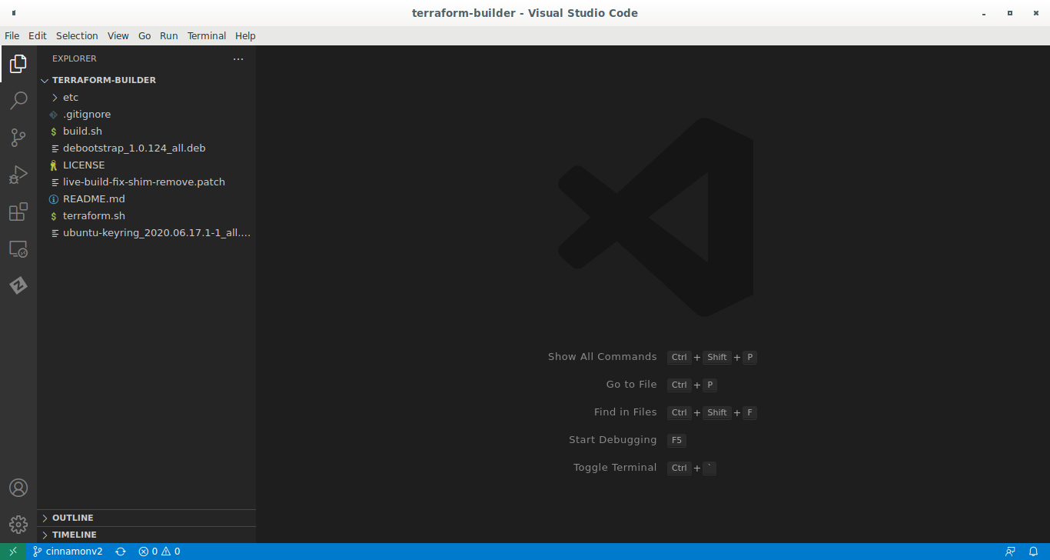
These files are mostly the README file, two Debian packages for the build script to work with, a patch file which fixes some small issues, a gitignore file which is a Git configuration file, the License file, and the build script which will be ran later in the build process. A closeup of the actual list of files is listed below.
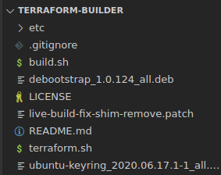
In the etc/ directory, is our desired configuration file. etc/terraform.conf,
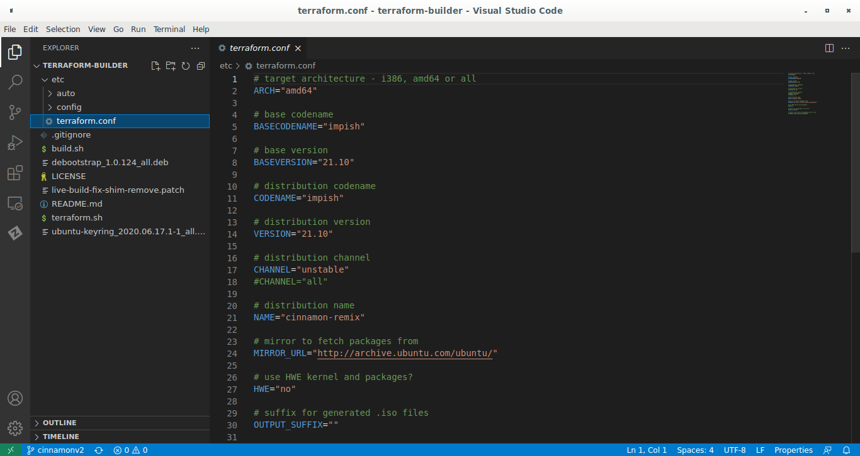
In the etc/terraform.conf file is a long list of changes that need to be made. Including various small strings to change for various purposes. This does not mean these are the only configurations, as in the etc/ directory has a sub-directory called etc/config/ which will be used later. There also the etc/auto/config file which does not need modification.
The changes that need to be made to the configuration file:
- Architecture (if applicable)
- Base version and version name
- Distribution version and version name
- The name of the distribution

Chapter 5.4.1: Modifying the architecture
The architecture, or arch, of the target system is important to set as it defines the set of devices that will be used. For our purposes we will be using the AMD64 architecture, which is compatible with x86_64 architecture devices – which calling both architectures the same isn’t necessarily incorrect.
Using the AMD64 architecture allows us to use our distribution on the vast majority of desktops and laptops on the market. However, your distribution will not work on all systems. M1 Mac devices, Raspberry Pi’s, most mobile devices, and even some servers use some variety of the Advanced RISC Machines (ARM) architecture. We will not be targeting this platform for now, but it is valuable to understand other architecture options for computers.

Chapter 5.4.2: Modifying the base/distribution version
This example will be using 22.04 Focal Fossa as a base. Note that there will be some package discrepancies between versions of Ubuntu.

Chapter 5.4.3: Changing the name of the distribution

Chapter 5.5: Package configuration
Before we can start adding packages to our distribution, we need to modify the current package configuration – including the removal of the current third-party repository that the Ubuntu Cinnamon Remix hosts its packages for development.
Here is what we need to do:
- Comment out, or remove, the APT package configuration that adds the cinnamon packages.
- Remove the packages from the package installation lists.

Chapter 5.5.1:APT Package Configuration files

5.5.2: Removing unneeded packages

Chapter 5.6: Adding packages

Chapter 5.7: GRUB/ISOLINUX configuration

Chapter 5.8: Building

Chapter 6: Fork using the Pop Builder

Chapter 6.1: Differences between Terraform

Chapter 6.2: Setting up your system

Chapter 6.3: Basic configuration

Chapter 6.4: Package configuration

Chapter 6.5: Adding packages

Chapter 6.6: Building

Chapter 7: Build tools for other operating systems

Chapter 7.1: ArchISO

Chapter 7.2: Linux Respin

Chapter 7.3: Linux Live System

Chapter 7.4: GhostBSD Builder

Chapter 7.5: Potabi Systems Builder

Chapter 7.6: FreeBSD Source

Chapter 8: How to continue

Chapter 8.1: Desktop Environments

Chapter 8.2: Kernel Versions

Chapter 8.3: Core Utilities

Chapter 8.4: Shells

Chapter 8.5: Applications

Chapter 8.6: Installers

Chapter 8.7: Open VS Proprietary

Chapter 8.8: Changing Base

Chapter 8.9: More than software

Chapter 9: Epilogue and Final Thoughts

Chapter 9.1: What we learned
We learned the initial basics of building an operating system by forking Ubuntu. We saw the difficulty and problems with the current methods of

Chapter 9.2: Is it still worth it?
This is an important question to ask. Even building the most simple fork imaginable requires a decent amount of effort, knowledge, and computational resources.
Remember, when answering this question, there are a few other questions needed to be asked alongside. Ask yourself:
- Do I have a vision for my operating system?
- Do I want to spend the time and effort making an operating system, or do I want something else?
- Am I willing to learn the highly technical aspects of building applications, shell scripts, packaging software, hosting packages, and everything else?

Those three questions are just the start of the process. While these questions might seem easy to answer, they aren’t.
Having a basic idea isn’t having a vision, which should be the first step in deciding when to actually build an operating system. If you want a hobby project, building an operating system is arguably not a good option for that either, as it’s a very time-consuming project – bordering on part time job – if you want to be serious with the project.
Your operating system project, if you choose to make one, will be complicated, difficult, and time consuming. If this is worth while to you, then build an operating system. While it’s possible for anyone to make a long-term operating system with enough grit and elbow grease, it still takes up a lot of time and effort for these developers.
It’s not that making a simple fork of Ubuntu is anything like running a Fortune 500 company with two people and a single pineapple, but that it’s more work than simply working on a video game, or basic mobile application.

Chapter 9.3: A thankless job
Something rarely mentioned is how truly thankless the job of building an operating system is. Many developers work for years making their dream operating system, and making it great for the masses to see. They post it online, advertise it a bit, and then people use it.
However, many developers look for consistent income, which is rare to find – especially in an open-source field where the operating system is still even more likely to succeed in growing a userbase. A userbase of a hundred would see very little, if any form of donation of time, effort, or resources.
While building a commercial operating system is an option, it makes it a lot less likely to be adopted by the masses.
One of the main issues Ubuntu faced in development of its desktop operating system was that few really chose to donate. The twelve million dollars for the Ubuntu Edge phone came from just under thirty thousand donors, or around $415 per donor. This was a failure in Canonical’s eyes, but what would be considered a success for most distributions, which rarely see more than a thousand dollars a year in donations, per month for larger distributions.
People often just complain about small issues that could be very difficult to be fixed, and assume a developer is willing to work for free because that’s how they think open-source works.

Chapter 9.4: Build an imagination
Being pragmatic is good and all, but does come with its own fallbacks. Building an operating system are jobs that require lots of time, effort, and imagination.
Building an imagination means you build the tools to see new tools. An operating system is a tool, and to only see it in a pragmatic sense means to only see it for what it is.
To see an operating system as more than just a few small aspects of pure software. Building better tools means to take what is there, and expand on it in ways that may not immediately make sense.
Programming is an art-form in its own right. Meaning you are the author of a new tool to change the world in a new way.

Chapter 9.5: To conclude
Building a Linux distribution is a difficult but process, even when taking the easy-way. But to build a Linux distribution to say you did is also kind of worthless. If you want to make something new and special, all power to you, but if it is only for the gloating power, maybe building a Linux distribution isn’t right for you.
If you have a vision, a dream, an innovative idea that requires the building of a new Linux system, or general operating system, then make it. The only limits are your imagination, and your will to work.

